**Get request methods with Variables:**

For this first we need to set the Environment variables

Repetitive text in the api can be replaced by creating variables.Variables are created using Environments in Postman and its scope is within the collection only.

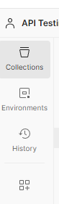

Second icon environment we need to click that it shows like create environment we can provide name and add the variables as given below.

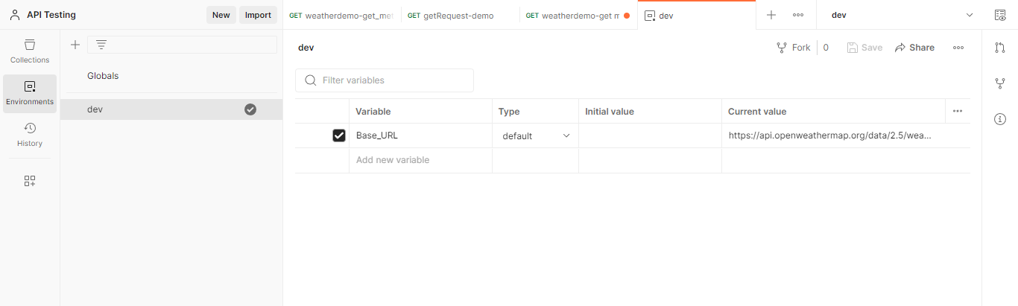

We pasted the repeated URl in the current value place and provide the variable name and copy that name.

Now we can get back to the request and paste the variable name like {{name of variable}}

Now also it shows invalid we need to add the environment to the request at top right dropdown and select the variable.

Now its shows like valid request we can send the request as I send the request I got the result as given below.

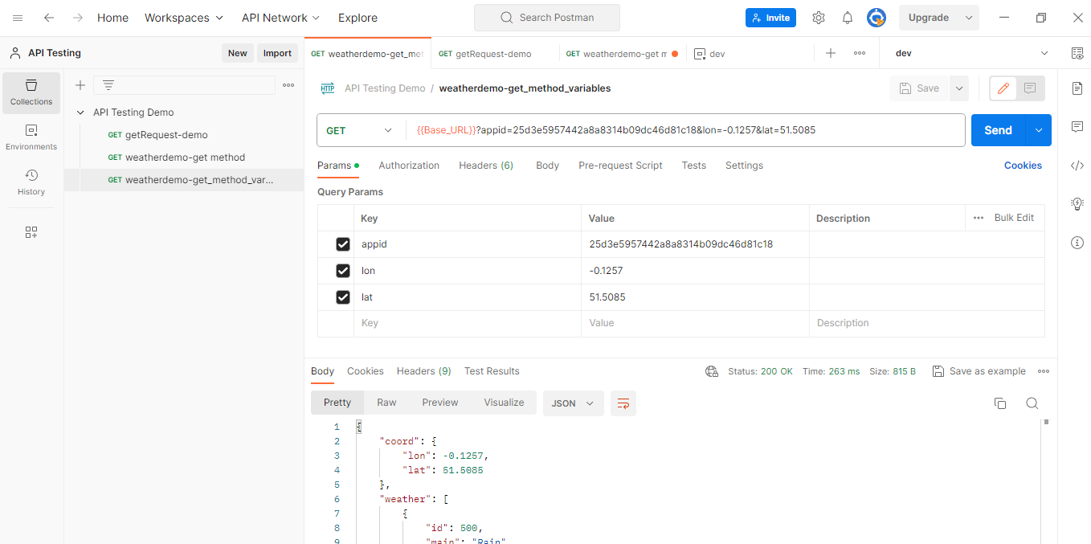

We can see that the request is executed and status is 200 .